**PRELIMINARIES**

ii

The Bachelor of Science in Information Technology is requiring a 486 hours of On-the-Job Training (OJT) exposure of the student in their field of specialization in the industry. On-the-Job-Training is job training that occurs in the workplace. It is part of a college curriculum that aims to train and orient students about the work and their future career. It is very important not only to teach students on their chosen career but to show students the reality about working.

It is a type of skill development where a trainee learns how to do the work through hands-on experience. On**-**the**-**Job Training is one method by which trainees are exposed with different work situation designed, to give trainees an opportunity to experience and a chance to apply the theories and computation that they have learned from the school. It allows those with no experience to work and to learn at the same time. It also helps the trainees to acquire relevant knowledge and skills by performing in actual work setting, and also in building up of the trainee’s competence. The training develops one’s professionalism in dealing with people. She/he will also be able to work well with everyone and she/he will have a good teamwork.

On-the-Job Training allows the trainee to get acquainted with the real professionals and to meet people having different positions in the company, either high or low. The trainee will be able to know how to adjust to other people’s personalities and attitudes. It can possibly be a source of recommendation when they take that big lift from being students to career professionals someday.

Trainees’ should realize the importance of OJT on their future career. Having a good performance during OJT is very important especially now that there's a tight competition towards job seekers and the high qualification of companies.

The trainees’ can bring fresh ideas into the organization. Given the opportunity to speak their thoughts freely and without fear, they may be able to contribute significantly in brainstorming sessions or research and eventually help improve the organization productivity.

Having a proper On-the-JobTraining helps in the preparation of future professionals for their future jobs. What the students learned in their On-the-Job Training, even the little things, can be applied when they are already working. Students will be trained not only academically but socially as well. The way they work and communicate with others will not be a problem for them anymore. It also gives the trainees the chance to immerse themselves in his/her chosen field, experience and learn the skills necessary to the industry he/she is interested in. Working with experienced staff, one will be able to observe how the job is done properly.

On-the-Job Training requires effort and seriousness. A trainee should take the On-the-Job Training or OJT seriously as it can be a powerful tool for a person in preparing for the next chapter of life as a professional.

**NARRATIVE REPORT**

**PRACTICUM/ON JOB TRAINING**

Conducted at:

**University of the Philippines Open University**

National Highway, Brgy. Maahas, Los Baños, Laguna

(UPOU Information and Communication Technology Development Office)

In Partial Fulfillment of the Requirements for

**BACHELOR OF SCIENCE IN INFORMATION TECHNOLOGY**

**IT 4230 OJT/PRACTICUM**

Submitted to:

**Ms.Myline S. Viňas**

OJT Coordinator

Submitted by:

**Mary Jane S. Pascua**

Trainee

A.Y 2016-2017

**APPROVAL SHEET**

iii

This narrative report attached here to submit by Mary Jane S. Pascua in partial fulfillment requirements for the program of Bachelor of Science in Information Technology is hereby accepted.

**Ms.** **Myline S. Viñas**

Practicum / Internship Coordinator

Accepted and approved as partial fulfillment for the Program Bachelor of Science in Information Technology

**Mr. Nomer B. Aguado**

Dean, College of Arts Sciences and Technology

**BIOGRAPHICAL SKETCH**

iv

On the 9th day of January, year 1997 a child was born in the province of Laguna under the Municipality of Calauan. It is the first daughter of Mr. Max E. Pascua, a tricycle driver and Mrs. Jenifer S. Pascua, a lovingly housewife. She was baptized under Roman Catholic Religion, and was named Mary Jane S. Pascua.

Presently, she was studying at Laguna University located at Bubukal, Sta.Cruz, Laguna, taking up the degree of Bachelor of Science in Information Technology. She finished her elementary education at Dayap Elementary School (2009) and her high school education at Dayap National High School (2013).

Mary Jane is motivated and always willing to learn new things, and hardworking. She also prioritizes the satisfaction of people with her work. She has knowledge in Programming (Visual Basic, and PHP), Microsoft Office (MS Word, Excel, PowerPoint and Access), and Adobe Creative Suite (Photoshop).

And she believes that her strong technical experience and education will make her a very competitive I.T Professional.

**ACKNOWLEDGEMENT**

v

This success of the trainee couldn’t be turn into reality without this following person who, with all they can, helped the trainee in making her On-the-Job-Training a possible one.

To her parents, for their unending love and support, for providing all her needs financially and morally, for their patience and understanding during her tiring days, and for being there for her no matter what. They serve as an inspiration to her, who keeps on encouraging her to always make the best out of everything.

To the institution where she is studying, Laguna University, where she continuously growing as a Bachelor of Science in Information Technology student.

To all professors, who shared and continuously sharing their knowledge with students like her and keep on molding her into a better person.

To the Information and Communication Technology Development Office, thank you for your warm welcome and for giving the trainee a one of a kind experience in having an OJT in your company. And for the chance that you have given to her to be with your team and for giving her more knowledge in this fast and furious world of Information Technology.

Above all, to our Almighty God, for His unconditional love and for all the blessing He is showering upon the trainee each day of her life. With love and gratitude, she thanks Him for guiding the trainee during her training and for making this On-the-Job Training a possible one. For giving her enough knowledge and ability to perform each task that was assigned to her. By His grace, she was able to finish this training without any conflict.

**TABLE OF CONTENTS**

vi

Title Page

Preliminaries

Approval Sheet

Biographical Sketch

Acknowledgement

Table of Contents

**TRAINING PROPER**

Profile of the Company/Organization

Training Experience

Insights

Summary

Recommendations

1. To the students
2. On the Practicum/OJT
3. On the Curriculum

**APPENDICES**

Endorsement Letter

Acceptance letter/form

Daily Time Record

Duties and Responsibilities

Certificate of Completion

Work Samples

Documentaries/Photographs

Evaluation Form

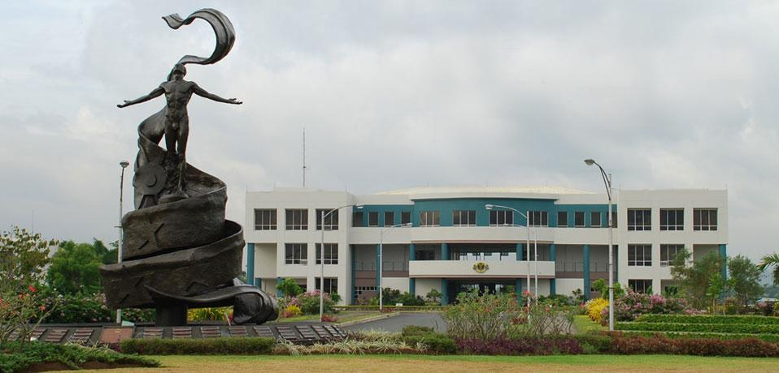**TRAINING PROPER**

**PROFILE OF THE COMPANY/ORGANIZATION**

**University of the Philippines Open University**

**Introduction**

Established on 23 February 1995, the University of the Philippines - Open University (UPOU) pioneered in online teaching and learning and continues to play a leading role in the study and practice of open learning and distance education in the Philippines.

UPOU is envisioned as a leader in teaching and learning in the digital age, helping to equip Filipinos with the knowledge and skills they need for life and work in the 21st century.

Our mission is to provide Filipinos everywhere access to quality higher education through innovative methods of teaching and learning that are designed to be responsive to their needs as well as to national development priorities. We uphold the values of scholarship, academic excellence, academic freedom, humanism, social responsibility, and service to the nation.

UPOU is also mandated to contribute towards upgrading the quality of the educational system of the country by developing innovative instructional strategies and technologies, and sharing these with other colleges and universities through cooperative programs.

[Republic Act 10650 (Open Distance Learning Law)](http://www.gov.ph/2014/12/09/republic-act-no-10650/) has tasked UPOU to assist relevant national agencies, higher education institutions, and technical and vocational institutions in developing their distance education programs through training, technical assistance, research and other academic programs.

We are the nation’s most comprehensive distance education institution, with three undergraduate programs, 13 post-baccalaureate certificate and diploma programs, 12 master’s programs, two doctoral programs and non-formal courses. We have a network of 8 learning centers and 20 testing centers in the country and abroad. This coupled with our ability to harness a wide range of digital technologies in education, have enabled us to build a global community of mostly Filipino learners in more than [70 countries.](http://192.168.3.4:81/79-upou/about-us/288-upou-students-location)

## Vision

The UP Open University shall be at the forefront of the knowledge society as a leading institution of open learning and distance education.

## Mission

The U.P. Open University seeks to provide wider access to quality higher education. It shall adhere to the highest standards of academic excellence, guarantee academic freedom, and encourage social responsibility and nationalistic commitment among its faculty, staff and students.

## Objectives

Specifically, the UPOU has the following goals:

* To provide opportunities for alternative access to quality higher education by offering baccalaureate and post-baccalaureate degree programs and non-formal courses by distance education.
* To develop a system of continuing education for sustaining professional growth and improving technical skills especially for those who cannot leave their jobs or homes for full-time studies; and
* To contribute towards upgrading the quality of residential instruction in the University and the educational system of the country, in general, by developing, testing and utilizing innovative instructional materials and technology, and sharing these with other colleges and universities through cooperative programs.

**Information and Communication Technology Development Office**

**(UPOU ICT Development Office)**

**Background and Rationale**

The UP Open University is in a unique position as the country’s leading institution in open and distance e-learning. As UPOU develops programs that attract a growing number of students from diverse geographic locations, it must continue to invest in various information and communications technologies (ICTs) that will allow its internal operations to be streamlined, automated and made accessible to students, faculty, staff and the general public. To date, almost 100% of UPOU’s courses are fully online.

The efficient use of available ICTs is key to the fulfillment of the UPOU’s mission to provide wider access to quality higher education and to live up to its identity as the Center of Excellence in Open and Distance Learning and as the Cyber University of the UP System.

**Description**

The Information and Communication Technology Development Office (ICTDO) is an office responsible for harmonizing the ICT systems and infrastructure at the CU level, as well as leading the development of appropriate, relevant and world-class ICTs for the effective delivery of quality open and distance e-learning.

The office is created by merging and redefining the functions of existing key offices that provide information and communications technology services, the Multimedia Center (MC) under the Office of the Chancellor, and the Management Information Systems Office (MISO) under the Office of the Vice Chancellor for Finance and Administration.

**Mandates**

The UPOU ICT Development Office leads the UPOU towards and integrated, interconnected, harmonized and interoperable ICT systems and infrastructure as well as the development of appropriate, relevant and world-class ICTs for the effective delivery of quality open and distance education in support of its thrust of academic and operational excellence thereby contributing to the remaking of the University of the Philippines as the great national university.

**Structure**

The office is under the Office of the Chancellor. It is headed by a Director with an Administrative Officer or Administrative Assistant as office support.

In order to perform network administrations, systems administration, management of information systems, application of academic technologies, development of ICT infrastructure and services, and technical support, the Office has three sections:

1. Network Administration and Technical Support

2. Systems Administration and;

3. Academic Technologies

**Organizational Chart**

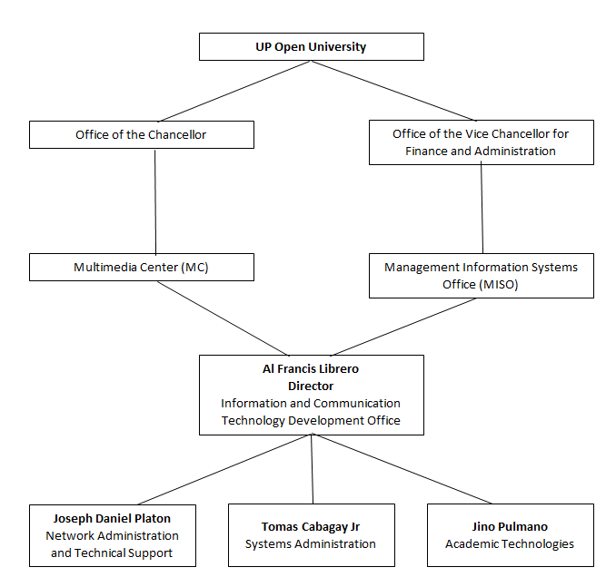

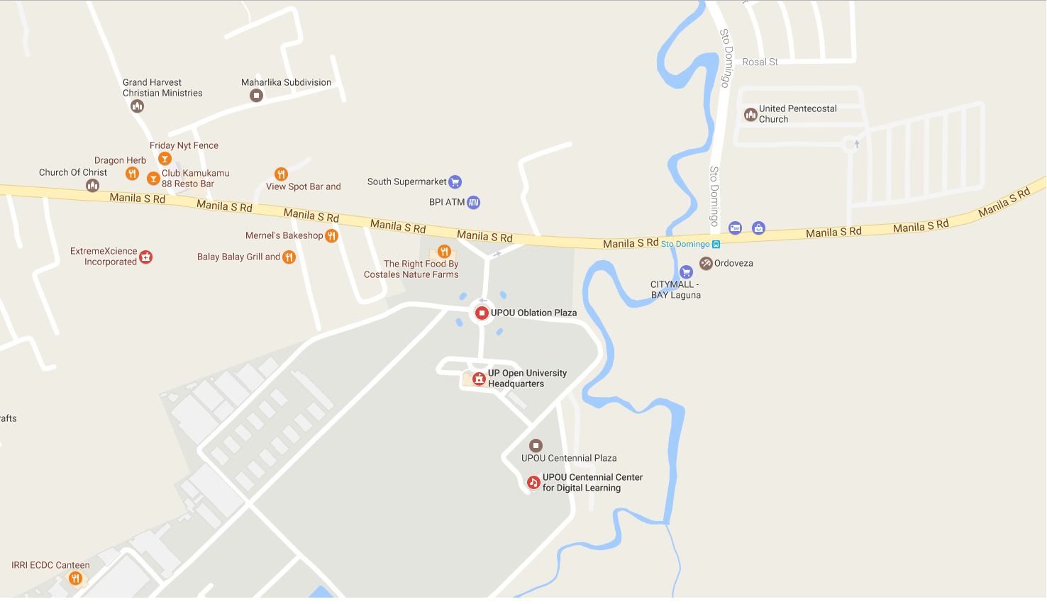**Location Map**

**UP Open University Headquarters**

National Highway, Brgy. Maahas

Los Baños, Laguna

Philippines

**Driving from Metro Manila**

1. Drive southbound along South Luzon Expressway (SLEX) and take the Calamba exit.

2. Drive along the Real Avenue and turn right at Crossing Calamba after Chowking.

3. Drive along the National Road until you see the Olivarez Plaza in Los Baños.

4. Drive past Olivarez Plaza and the Los Baños Junction, towards Sta. Cruz and San Pablo.

5. Approximately 5 minutes from the Junction, turn right to UP Open University, across the South Supermarket.

**Commuting from Metro Manila**

1. Take any public transportation traveling to Sta. Cruz, Laguna.

2. Inform the conductor that your destination is South Supermarket, Los Baños.

3. Get off at South Supermarket and cross the highway to UP Open University

**TRAINING EXPERIENCE**

The trainee, an Bachelor of Science in Information Technology student from Laguna University, had completed a total hour of four hundred eighty-six (486) hours in Information and Communication Technology Development Office (ICTDO), UP Open University, Brgy. Maahas, Los Baños, Laguna from February 01, 2017 to April 28, 2017.

Information and Communication Technology Development Office (ICTDO) – this is the office where the trainee was assigned to conduct her On-the-Job Training. On her first day of training, she was excited and somewhat nervous because of the new environment and the new people surrounding on her.

The training supervisor accompanied her to her table where she will be staying during her On-the-Job Training. During that moment she felt a bit nervous but she stayed calm and cool. The first task that her training supervisor asked to do is to Install, explore Joomla and download Purity III theme and look for different image slider plugin. After, there will be having an Initial web application project – Applying Joomla with OVCAA website. The trainee took three (3) days to familiarize and explore the function of the joomla for their web application project. It is not as easy as you think because the trainee doing is more complicated than you think. It shows the real work how to do a task working with joomla.

As days went by, the trainee improved herself, eager to learn to show them that she can handle whatever task they give and to prove that she can do it. And her first week was really a good start and she was motivated to perform excellently because of what she had accomplished and because of her supervisor who is very accommodating and kind.

A few weeks ago, the trainee had a new task need to do, she and her co-trainee was need to develop a web application project – UPOU Scribd Google Sign-in File Upload System. This task was very challenging because the trainees will be the one who will create codes manually for this project. Their skills need to apply was Object Oriented Programming, PHP/MySQL, and Bootstrap CSS Framework working with github. It’s a pleasure to have a project like this because it enhanced the knowledge and skills of the trainees. And there were many tasks we faced in staying in Information and Communication Technology Development Office.

The trainee enjoyed her On-the-Job Training in Information and Communication Technology Development Office, UP Open University. It served as the beginning, a stepping stone to the real life of being an Professional Information Technology. It helped the trainee acquire relevant knowledge and skills by performing in an actual work setting. And the trainee was blessed and thankful to her supervisor Mr. Tomas Cabagay Jr. for sharing what he knew, and for the guidance and training at the ICTDO, UP Open University. To all Information and Communication Technology Development Office family, thank you, whose kindness and support in the training was overwhelming.

**INSIGHTS**

On**-**the-Job Training (OJT) is designed to provide graduating students to learn from a specific number of tasks within a certain organization, in order that they can apply their knowledge, and skills on technical operations towards works or tasks being assigned. On-the-Job Training provides the trainee an opportunity to know how to perform a duties and responsibilities effectively for her future career.

Having an On-the-Job Training also known as OJT at University of the Philippines Open University (UPOU) from the department of Information and Communication Technology Development Office (ICTDO), there are lots of theories which the trainee applied during the whole duration of her internship. This training is very objective in order to gain actual work experiences within a specific period of time. It also helps the trainee to understand better the work values or ethics, discipline and professionalism at work.

In Information and Communication Technology Development Office Department (ICTDO), they have been kind enough and patient to train and teach the trainee the things she needed to learn in their field of services. The training made her to be a better person through the challenges, adjustments, and difficulties that she faced and encountered during the whole training. And the trainee was very proud to say that being part of this department she becomes more knowledgeable, skillful and responsible.

**SUMMARY**

The training I had in the Information and Communication Technology Development Office, UP Open University is an unforgettable moment. The trainee became familiar with the different work of a Professional Information Technology. She learned to be more sociable and to adjust herself in the environment where she was working at and who she working with.

In her three months of staying in Information and Communication Technology Development Office, she learned many things not only those things that are related to her course but also the things that molded her into a better person right now. She learned to become hard-working person and to appreciate even the simplest task given to her. During her On-the-Job Training, The trainee supervisor always encouraging and motivating the trainees to do the best always and fight whatever happens. He always said to us when we creating a system, we can do it, nothing is impossible.

After the training, the trainee realized that On-the-Job Training is not just a requirement to be completed but it is an opportunity to show what skills, knowledge, and talents she have and also an opportunity to experience the feeling of being a professional Information Technology already.

**RECOMMENDATIONS**

1. **To the students**

The students must have a good company/institution that would give them a good training ground and would enhance their knowledge and capabilities. And also it will help the students to boost up its skills and self-esteem in the field of Information Technology.

1. **On the Practicum/OJT**

On-the-Job Training is one method by which trainees are exposed with different work situation designed, to give trainees an opportunity to experience and a chance to apply the knowledge and skills that they have learned from the school. And the trainee recommends to the company/institution to continue their On-the-Job Training for the students to gain and improve the skills and knowledge they have and also to give them a proper compensation/ allowance to motivate and finished the task.

1. **On the Curriculum**

Practicum coordinator should closely monitor the students to be able to know what the trainees’ doing in the company/institution.

**APPENDICES**

**ENDORSEMENT LETTER**

**ACCEPTANCE LETTER/FORM**

**DAILY TIME RECORD**

**For the month of February 2017 (Monday-Friday)**

|  |  |  |  |  |  |
| --- | --- | --- | --- | --- | --- |
| **DAY** | **A.M.** | | **P.M.** | | **HOURS** |
| Arrival | Departure | Arrival | Departure |
| **1** | 7:30 | 12:00 | 1:00 | 6:10 | 9:40 |
| **2** | 7:15 | 12:00 | 1:00 | 6:15 | 10:00 |
| **3** | 7:55 | 9:00 | 2:06 | 6:25 | 5:24 |
| **6** | 7:30 | 12:00 | 1:00 | 5:55 | 9:25 |
| **7** | 7:10 | 12:00 | 1:00 | 6:20 | 10:10 |
| **8** | 7:15 | 12:00 | 1:00 | 5:15 | 9:00 |
| **9** | 7:00 | 12:00 | 1:00 | 6:11 | 10:11 |
| **10** | 8:10 | 12:00 | 1:00 | 4:45 | 7:35 |
| **13** | 7:15 | 12:00 | 1:00 | 6:00 | 9:45 |
| **14** | 7:24 | 12:00 | 1:00 | 6:20 | 9:56 |
| **15** | 7:15 | 12:00 | 1:00 | 6:05 | 9:50 |
| **16** | 8:00 | 12:00 | 1:00 | 6:20 | 9:20 |
| **17** | 8:25 | 12:00 | 1:00 | 5:15 | 7:50 |
| **20** | 7:35 | 12:00 | 1:00 | 6:06 | 9:31 |
| **21** |  |  |  |  |  |
| **22** | 7:25 | 12:00 | 1:00 | 6:09 | 9:44 |
| **23** | 7:17 | 12:00 | 1:00 | 2:36 | 6:19 |
| **24** | 8:25 | 12:00 | 1:00 | 3:44 | 6:19 |
| **27** |  |  |  |  |  |
| **8** | 7:50 | 12:00 | 1:00 | 12:50 | 4:00 |
| **TOTAL HOURS** | | | | | **153.59** |

*I certify on my honor that the above is a true and correct report of the hours of work performed, record of which was made daily at the time of arrival and departure from office.*

**For the month of March 2017 (Monday-Friday)**

|  |  |  |  |  |  |
| --- | --- | --- | --- | --- | --- |
| **DAY** | **A.M.** | | **P.M.** | | **HOURS** |
| Arrival | Departure | Arrival | Departure |
| **1** | 8:17 | 12:00 | 1:00 | 6:00 | 8:43 |
| **2** | 7:25 | 12:00 | 1:00 | 6:07 | 9:42 |
| **3** | 8:03 | 10:13 | 1:50 | 5:45 | 6:05 |
| **6** |  |  |  |  |  |
| **7** | 7:22 | 12:00 | 1:00 | 6:18 | 9:56 |
| **8** | 7:30 | 12:00 | 1:00 | 4:05 | 7:35 |
| **9** | 7:20 | 12:00 | 1:00 | 6:25 | 10:05 |
| **10** | 8:11 | 12:00 | 1:00 | 5:45 | 8:34 |
| **13** | 7:24 | 12:00 | 1:00 | 6:17 | 9:53 |
| **14** | 7:24 | 12:00 | 1:00 | 6:18 | 9:54 |
| **15** | 7:11 | 12:00 | 1:00 | 6:22 | 10:11 |
| **16** | 7:10 | 12:00 | 1:00 | 6:21 | 10:11 |
| **17** | 8:17 | 12:00 | 1:00 | 5:20 | 8:03 |
| **20** | 7:12 | 12:00 | 1:00 | 6:14 | 10:02 |
| **21** | 7:11 | 12:00 | 1:00 | 6:12 | 10:01 |
| **22** | 7:15 | 12:00 | 1:00 | 6:09 | 9:54 |
| **23** | 7:15 | 12:00 | 1:00 | 6:24 | 10:09 |
| **24** | 8:15 | 12:00 | 1:00 | 5:45 | 8:30 |
| **27** |  |  |  |  |  |
| **28** | 7:20 | 12:00 | 1:00 | 6:27 | 10:07 |
| **29** | 7:06 | 12:00 | 1:00 | 6:17 | 10:11 |
| **30** | 7:15 | 12:00 | 1:00 | 6:34 | 10:19 |
| **31** |  |  |  |  |  |
| **TOTAL HOURS** | | | | | **188.05** |
|  | | | | | |

*I certify on my honor that the above is a true and correct report of the hours of work performed, record of which was made daily at the time of arrival and departure from office.*

**For the month of April 2017 (Monday-Friday)**

|  |  |  |  |  |  |
| --- | --- | --- | --- | --- | --- |
| **DAY** | **A.M.** | | **P.M.** | | **HOURS** |
| Arrival | Departure | Arrival | Departure |
| **3** | 7:17 | 12:00 | 1:00 | 6:11 | 9:54 |
| **4** | 7:25 | 12:00 | 1:00 | 6:22 | 9:57 |
| **5** | 7:22 | 12:00 | 1:00 | 6:25 | 10:03 |
| **6** | 7:28 | 12:00 | 1:00 | 6:35 | 10:07 |
| **7** | 8:34 | 12:00 | 1:00 | 5:18 | 7:44 |
| **10** | 7:29 | 12:00 | 1:00 | 6:13 | 9:44 |
| **11** | 7:34 | 12:00 | 1:00 | 5:40 | 9:06 |
| **12** | 8:16 | 12:00 | 1:00 | 12:22 | 4:06 |
| **13** |  |  |  |  |  |
| **14** |  |  |  |  |  |
| **17** | 7:34 | 12:00 | 1:00 | 6:07 | 9:33 |
| **18** | 7:20 | 12:00 | 1:00 | 6:10 | 9:50 |
| **19** | 7:09 | 12:00 | 1:00 | 6:07 | 9:58 |
| **20** | 7:01 | 12:00 | 1:00 | 6:18 | 10:17 |
| **21** | 8:00 |  |  | 5:00 |  |
| **24** | 7:22 | 12:00 | 1:00 | 6:10 | 9:48 |
| **25** | 7:22 | 12:00 | 1:00 | 6:24 | 10:02 |
| **26** | 7:50 | 12:00 | 1:00 | 6:08 | 9:18 |
| **27** |  |  |  |  |  |
| **28** | 8:18 | 12:00 | 1:00 | 5:45 | 8:27 |
| **TOTAL HOURS** | | | | | **147.54** |

*I certify on my honor that the above is a true and correct report of the hours of work performed, record of which was made daily at the time of arrival and departure from office.*

**DUTIES AND RESPONSIBILITIES**

The trainee duties and responsibilities in Information and Communication Technology Development Office (ICTDO), UP Open University are the following:

* Installation and Customization of Joomla and download Purity III theme and look for different image slider plugin.
* Initial enhancement of Ovcaa Website by applying the Purity III theme.
* Installation and familiarization in composer/ Yii framework.
* Develop web application project – UPOU Scribd Google Sign-in File Upload System.
* Explore Github and learned how to use command using git bash.
* Migrate all articles inside the old UPOU website to the new template of UPOU website using joomla.

**CERTIFICATE OF COMPLETION**

**WORK SAMPLES**

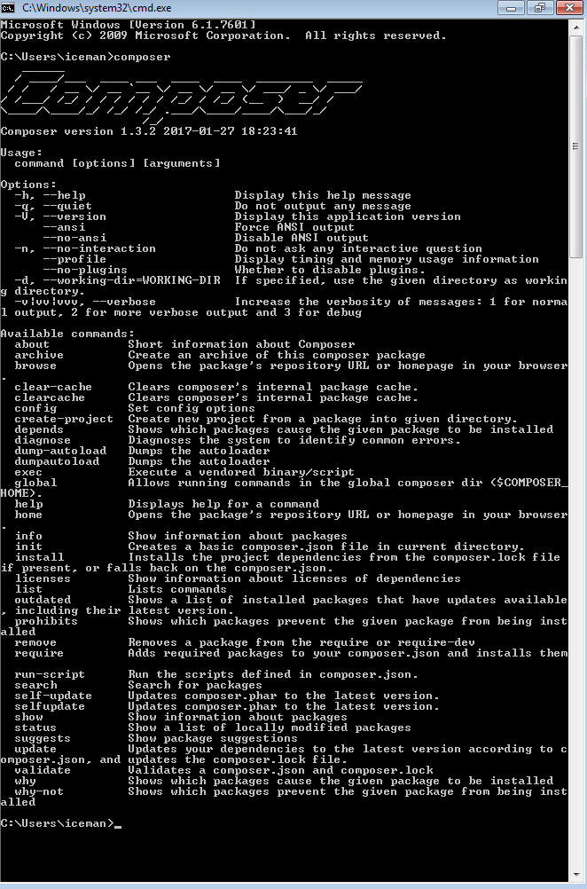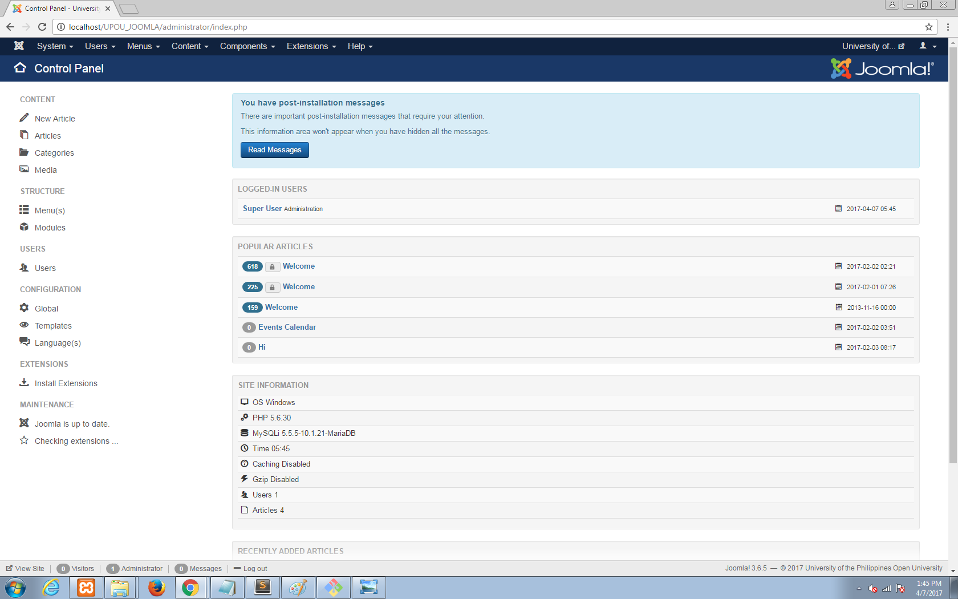**(Languages Used)**

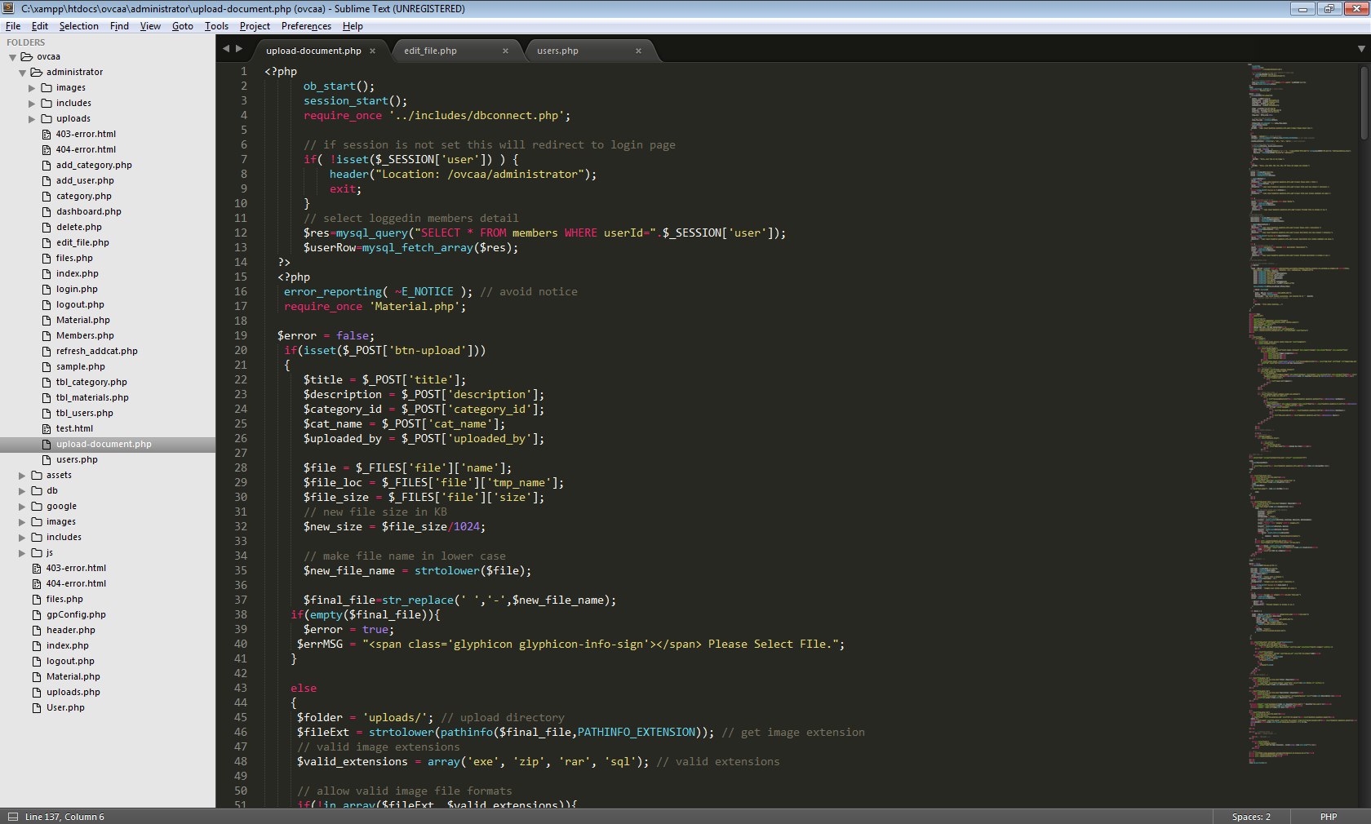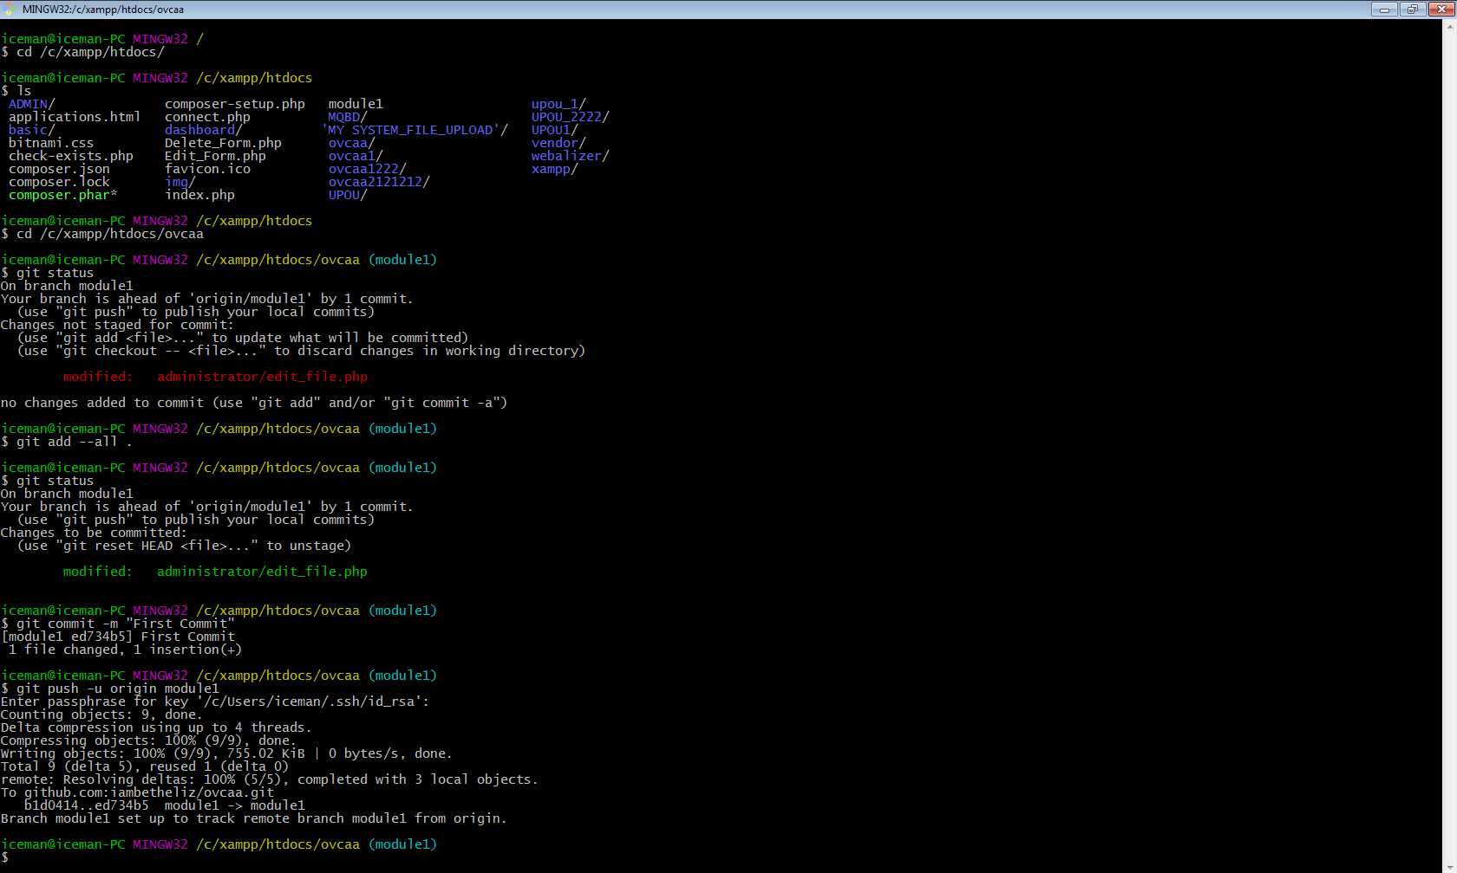 Joomla Composer

Git Bash Sublime Text

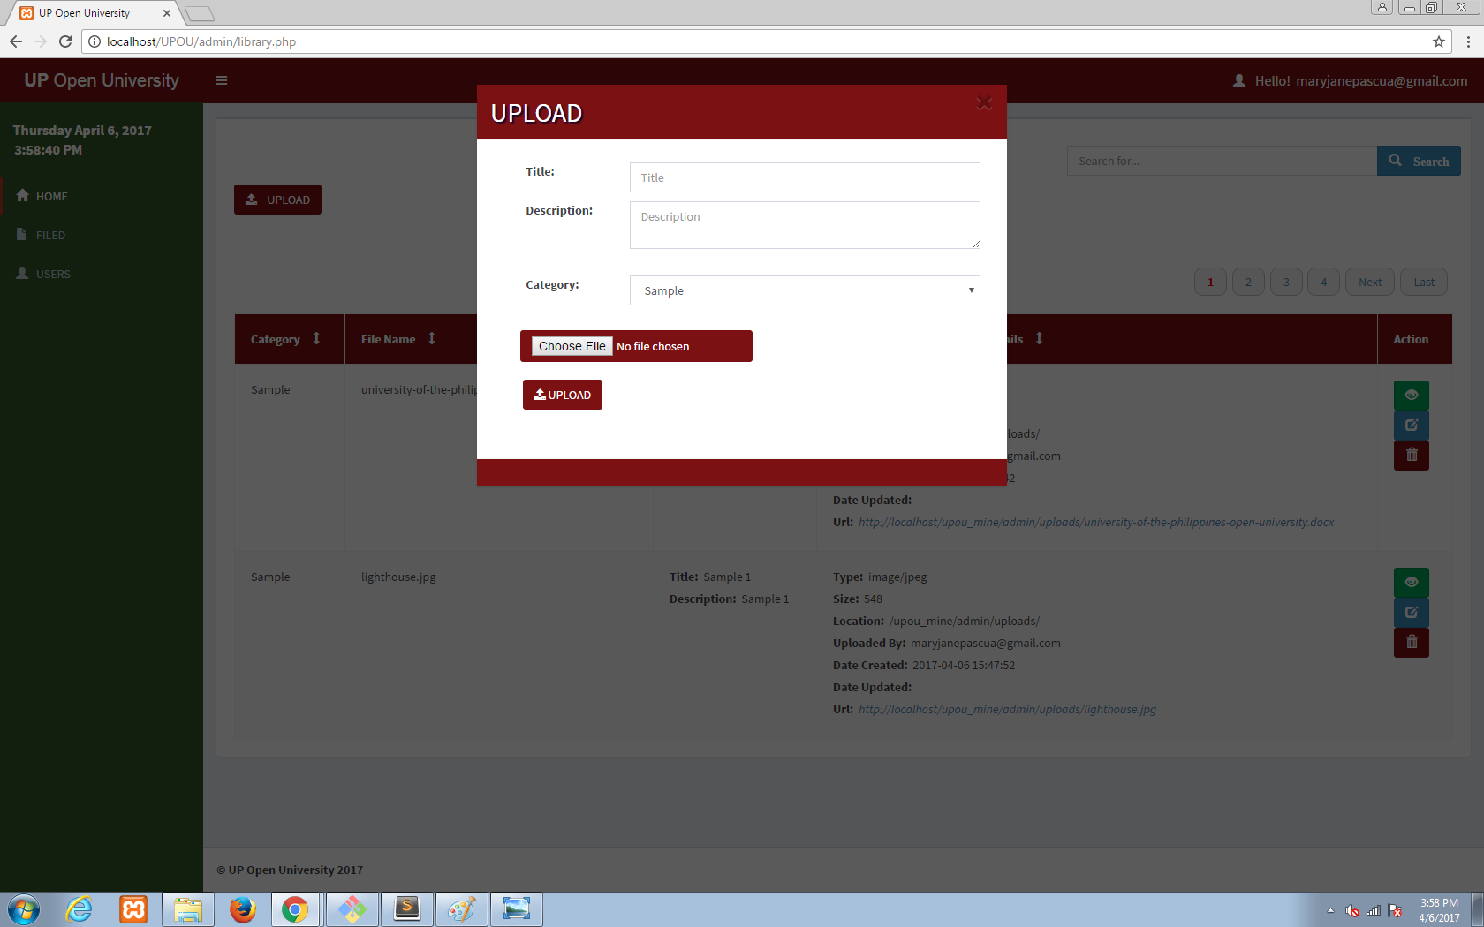**( Web Application Project – UPOU Scribd Google Sign-in File Upload System)**

Google Sign-in Web Application Upload File

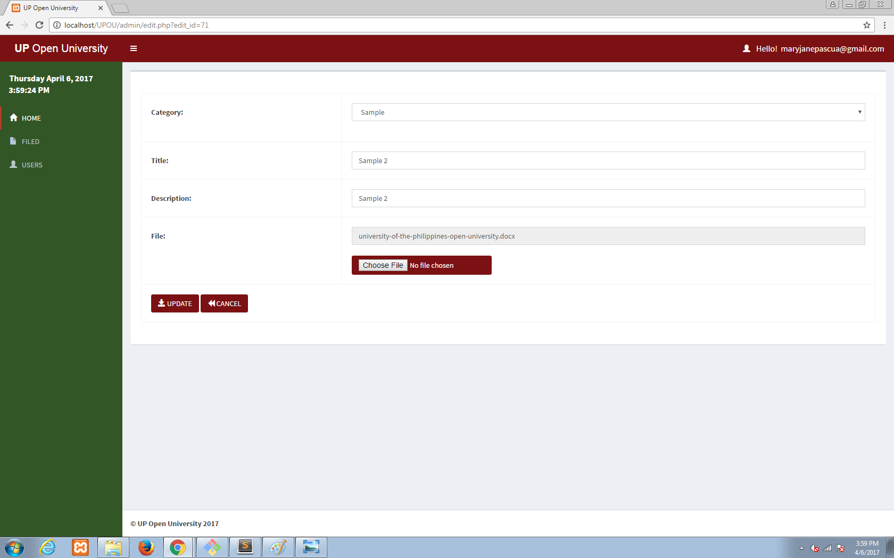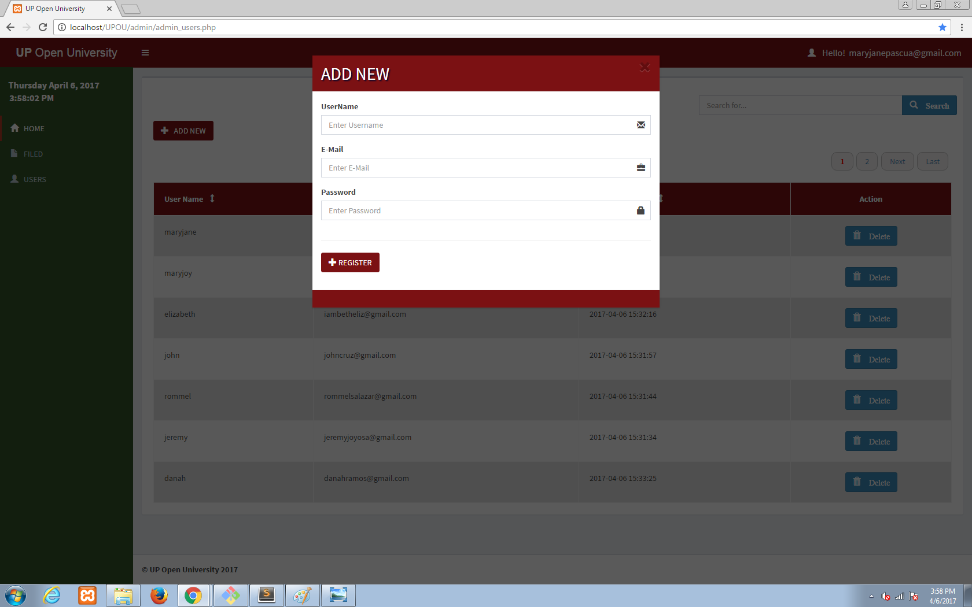

Add New User Edit File

**(University of the Philippines Open University “UPOU” Website)**

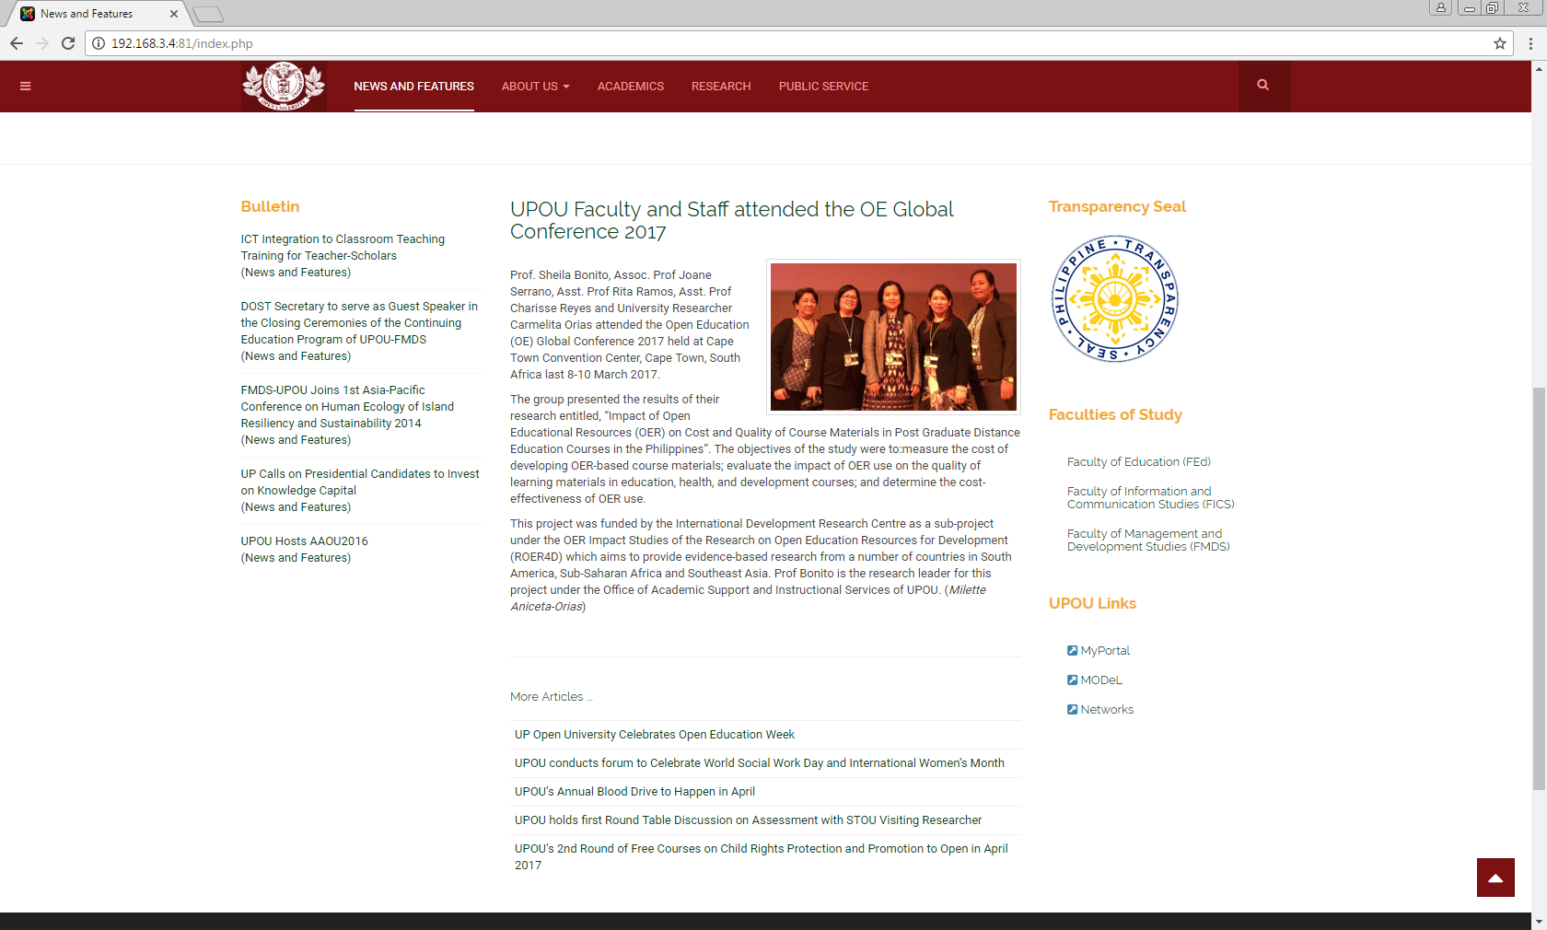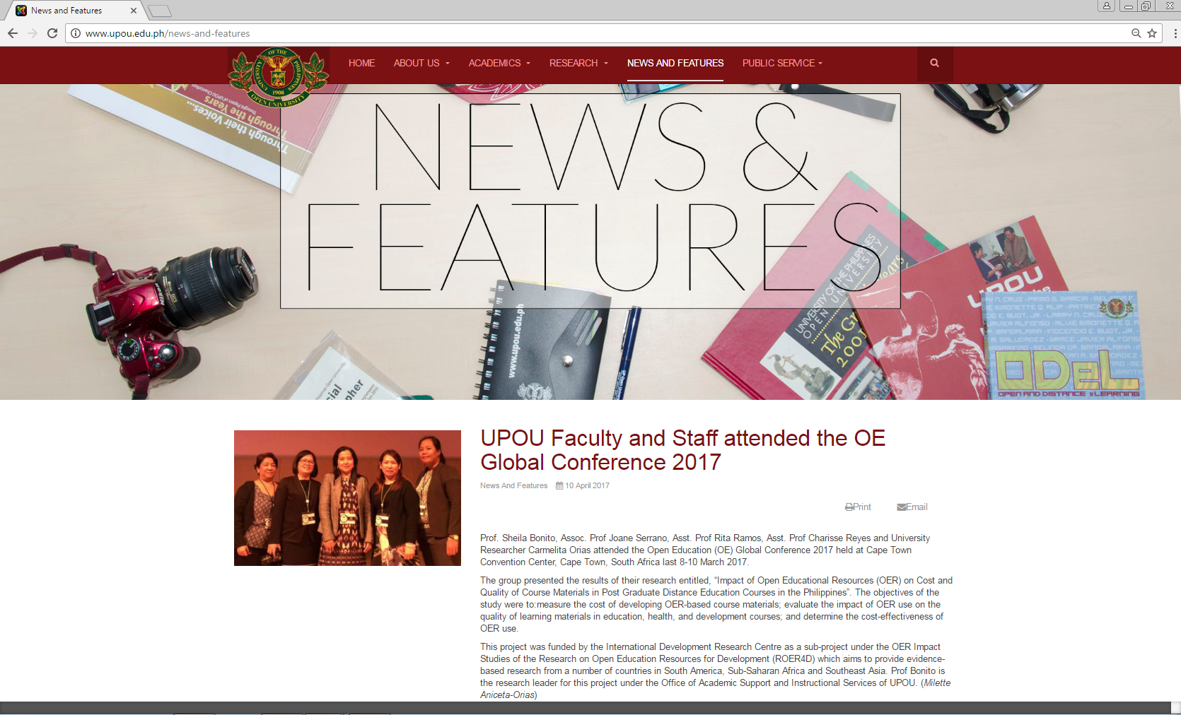Migrating all articles inside the old UPOU website to the new template of UPOU website.

UPOU Website (Old) UPOU Website (New)

**(OVCAA Website)**

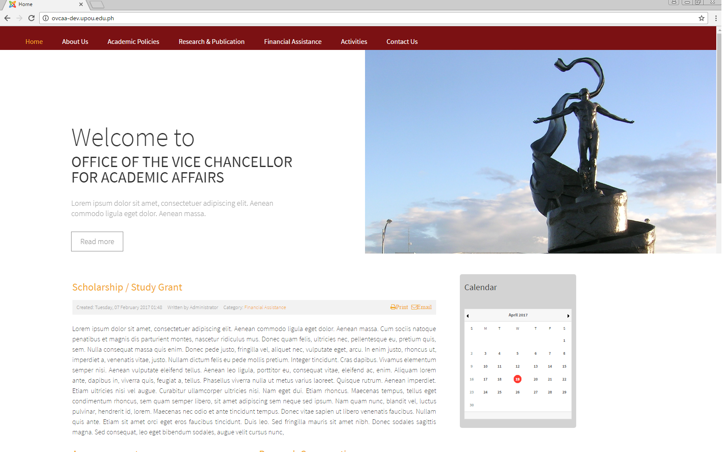Initial enhancement of ovcaa website.

**DOCUMENTARIES/PHOTOGRAPHS**

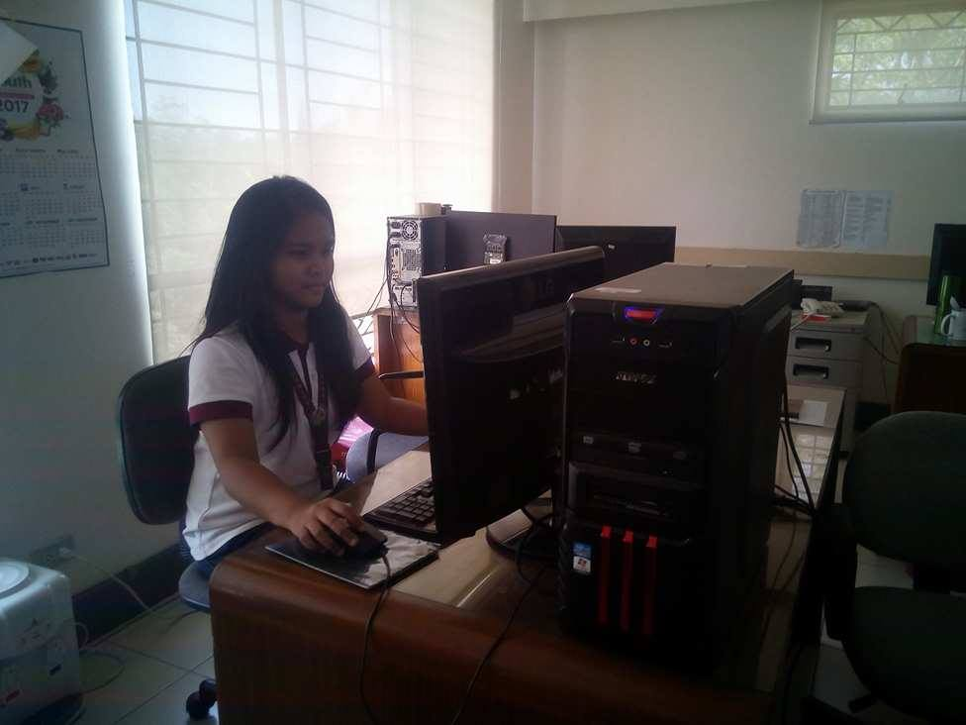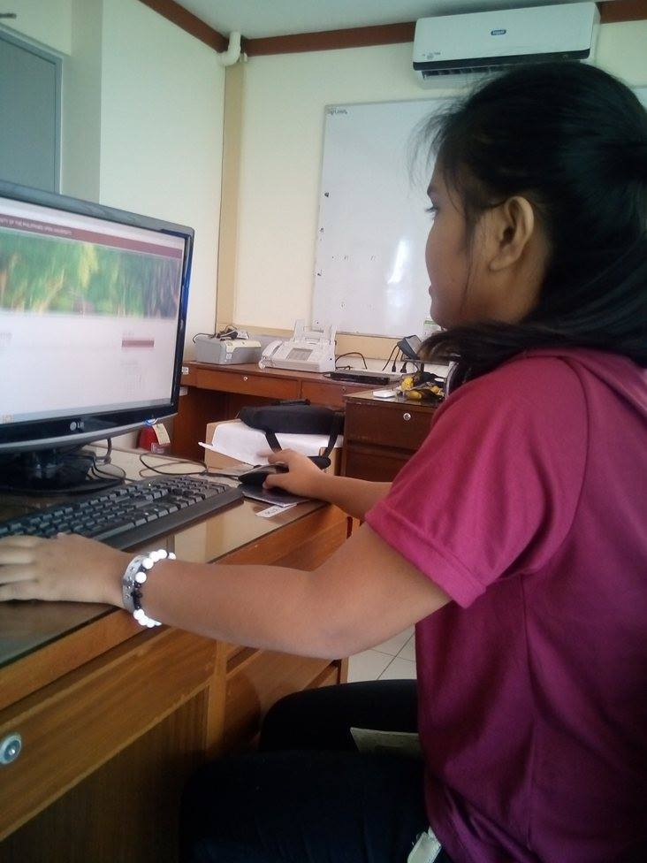

Designing the OVCAA Website. Migrating all articles inside the UPOU Website.

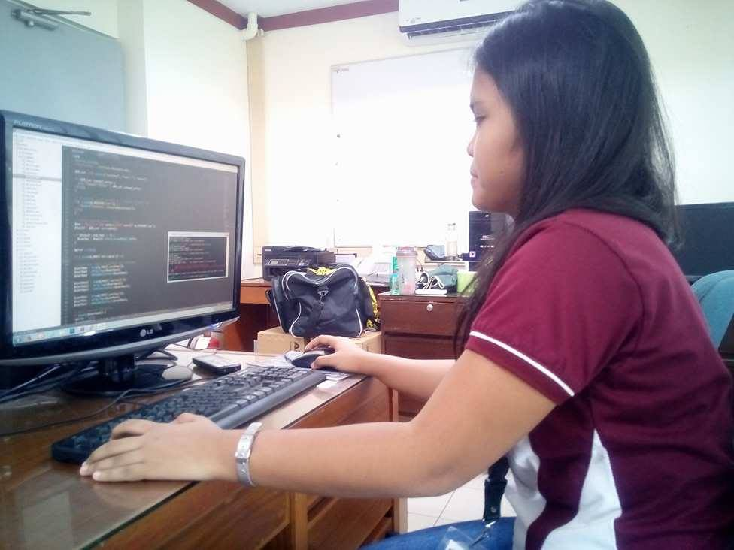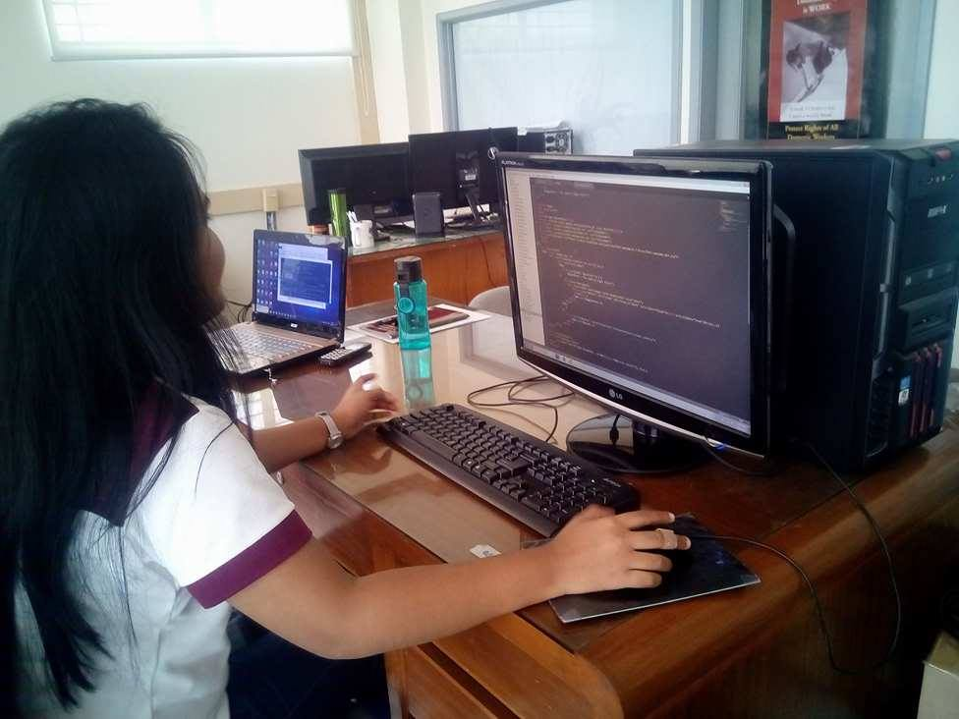

Working with sublime text and git bash for developing “Scribd UPOU Web Application Google Sign-in”.

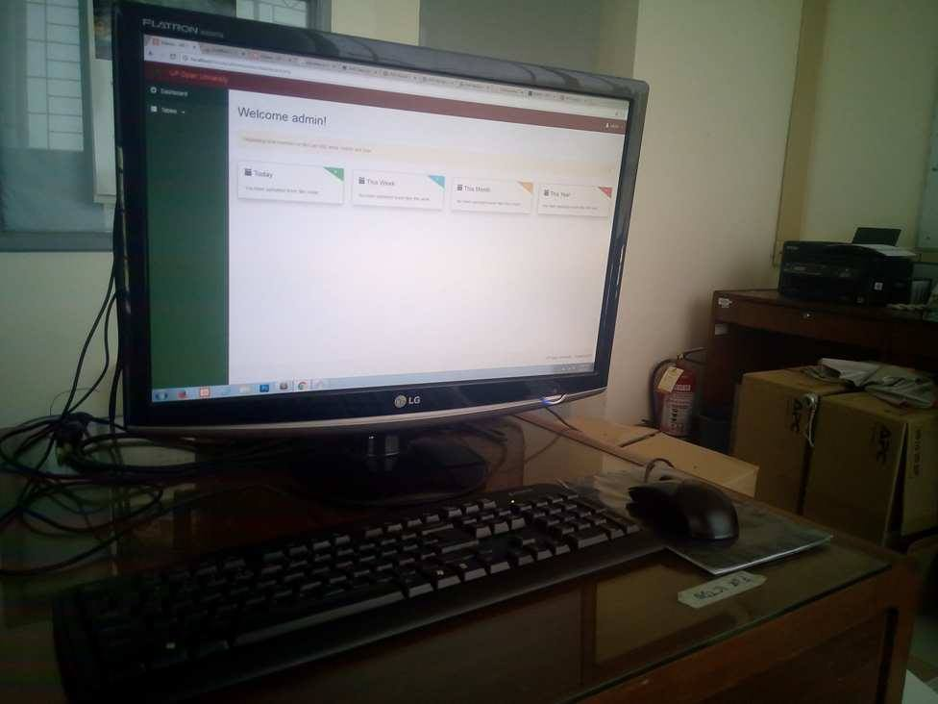

The trainee Personal Computer

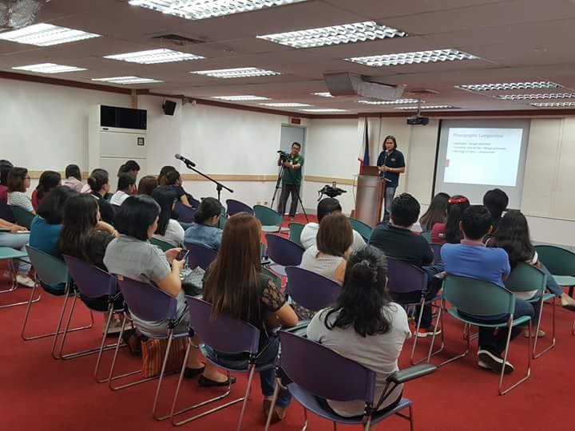

UPOU conducts a seminar entitled “Eyes and Mind: The Basics of Photographic Composition” with Asst. Prof.Al Librero as resource person at the UPOU Audiovisual Room.

**Curriculum Vitae**



**MARYJANE S. PASCUA**

Brgy.Silangan St. Dayap Calauan, Laguna 09274919137 maryjanepascua89@gmail.com

**Objective**

Seeking a challenging position which will allow me to further utilize my skills, knowledge and acquire new abilities.

**Technical Skills**

* + - * Programming (Visual Basic, and PHP)
* Microsoft Office (MS Word, Excel, PowerPoint and Access)
* Adobe Creative Suite (Photoshop)

**Personal Skills**

* High level of maturity and sense of responsibility.
* Highly resourceful, objective and reliable.
* Ability to work in a team driven environment.
* Motivated and always willing to learn new things.

**Seminars Attended**

**ISITE CALABARZON: Integrated Southern Tagalog**

Association of Information Technology Education – 1st

Regional Students Conference

“Shaping the Future of Information Technology Education”

Colegio de San Juan de Letran, Calamba, Laguna

October 2015

**Y4IT: 12th Youth Congress on Information Technology**SMX Convention Center, Pasay City  
September 2015

**ISITE CALABARZON: Integrated Southern Tagalog**

Association of Information Technology Education

"Cyber Security: The Present and Beyond"

Lyceum of the Philippines University, Batangas

December 2015

**ISITE CALABARZON: Integrated Southern Tagalog**

Association of Information Technology Education

“Seminar on Thesis and Capstone Writing”

De La Salle University, Lipa City, Batangas

February 2016

**Educational Attainment**

Tertiary : **LAGUNA UNIVERSITY**

Bubukal, Sta. Cruz, Laguna

Bachelor of Science in Information Technology

2016 – up to present

Secondary : **DAYAP NATIONAL HIGH SCHOOL**

Dayap Calauan, Laguna

2012 – 2013

Primary : **DAYAP ELEMENTARY SCHOOL** Dayap Calauan, Laguna

2008 – 2009

**Character References**

**Mr. Marlon L. Atanacio**

Brgy. Maahas,   
Los Baños, Laguna

Program Chair

IT Department

**Ms. Imelda B. Merjilla**

Magdalena,

Laguna

Professor  
IT Department

**Ms. Myline S. Viñas**

Brgy.Mayundon,  
Los Baños, Laguna

Professor

IT Department

**Personal Information**

Age : 20 years old

Gender : Female

Height : 5’2

Weight : 50 kg

Date of Birth : January 09, 1997

Place of Birth : Barangay Dayap Calauan, Laguna

Nationality : Filipino

Religion : Roman Catholic

Status : Single

Language(s) : English / Tagalog

*I the undersigned do here by that the information mentioned are true and correct to the best of my knowledge.*

**MARYJANE S. PASCUA**

**(**Applicant)

**EVALUATION FORM**